Extended Learning Partnerships: Connecting Art, Academics and the Community

ArtsTECH Academy @ University City High School, San Diego

Presenters: Lauriel Adsit, Andy Zafuto

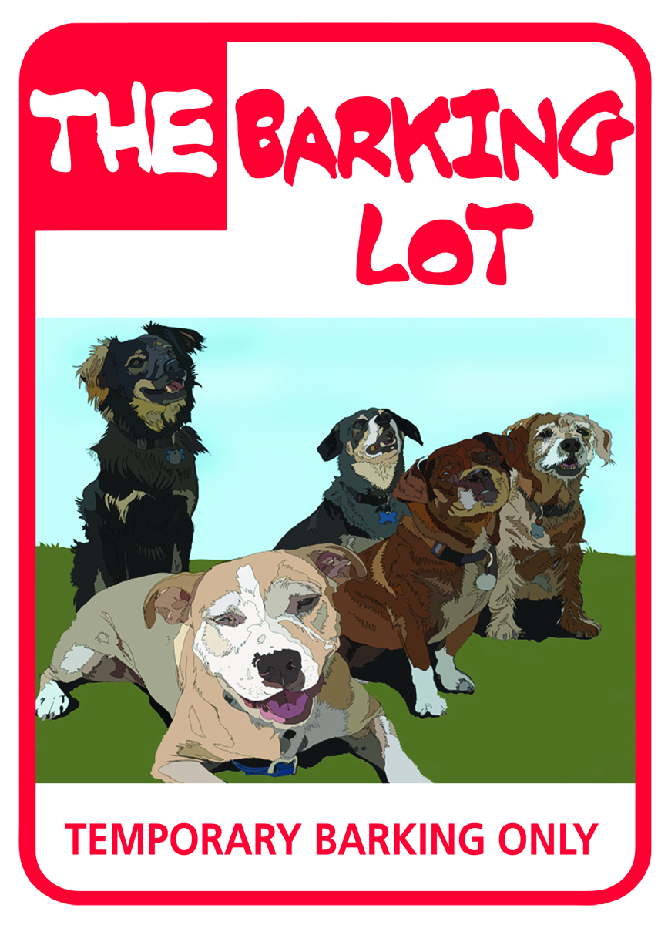

Extended Learning Partnerships: Connecting Art, Academics and the Community

Community Partnership with The Barking Lot

Project Theme: “Giving Back to Man’s Best Friend”

- Connection to the real world through community service-based learning by supporting and promoting a nonprofit animal rescue center called The Barking Lot.
- Education of the public and our students regarding humans’ responsibilities toward dogs.
- Study of canine/human relationships throughout history and recurrent in the arts, humanities and sciences.

The Project

- Media related to The Barking Lot (t-shirts, pamphlets, posters)
- Public service announcements to advertise The Barking Lot

How the project is linked to our academy career focus: Arts, Media, & Entertainment.

- Students will use elements of marketing, design, layout, and production.
- Students will engage in video/audio production.
- Students will write and perform skits, public service announcements and short films.

Essential (Driving) Question
How can we stop the neglect and abuse of man’s best friend?

Identify Key Questions
Break down the overall concept of the essential question into smaller parts:
1. Theatre Arts/Design in Mixed Media: How can we portray animals in media so that empathy and awareness are created not only amongst students but within the public at large?

2. Social Studies: What historical events help raise awareness of the importance of dogs and their vast contributions to society? (i.e.; war dogs, PTSD dogs, seeing eye dogs, herding dogs, hunting dogs, therapy dogs, etc.)

3. English: How can we use technical writing skills to create informational brochures that will aid in the endeavor of educating the public and students on issues regarding animal care? (i.e.; nutrition, spaying/neutering, exercise, flea care, etc.

Industry Professionals and/or Postsecondary Education Partners

The industry professionals and/or postsecondary education partners who could help with identifying authentic connections, could provide specialized instruction and mentoring, and who could evaluate student work.
- Brent Altomare, “Groovy Like a Movie”
- Chris and Alyson Rynne, lighting technicians/event planners
- Helen Woodward Animal Shelter
- Pug Rescue San Diego

Academic and Technical Rigor
Knowledge areas: Technical writing (ELA), raising the awareness of the general public through the arts and technology, analysis of the history of canine/human relationships (World History, ELA).
Enduring understandings: Community service/active citizenship, engaging in critical thinking and problem-solving, technological skills, professional interaction (“soft”) skills, identification/evaluation of one’s role/responsibility as a citizen.
Abstract thought, solving problems as members of creative teams, time management, communication/diplomacy.

Applied Learning
Students will create a media-based campaign consisting of live performances, video PSA’s and consumables (e.g. pamphlets, posters, book bags) drawing awareness to the plight of dogs in rescue facilities and what people can do to help.
Collaborative citizenship, effective communication, independent critical thinking, technological skills, setting goals and creating a plan to achieve them.

Active Exploration
A field trip to The Barking Lot or another animal shelter, independent research, after-school collaboration, cold calls and contacts.
Digital research, interviewing and observing, gathering and reviewing information, community outreach and networking.

Adult Connections
Mentorships/internships, guest speakers, online communication with industry professionals and advisory board members.
A graphic designer will help students create logos, posters, pamphlets, etc.; The Barking Lot’s Volunteer Coordinator will speak to the class and be available for online mentorship and guidance.

Assessment Practices
Direct contact with adults, peer review/critical friends.
Rubrics, peer review, teacher consultations, industry standards.
Project Implementation:
- Introduce driving question
- Students view previous mock-up/ “dry run” consumables
- Core content teachers begin frontloading processes
- Guest speakers present to students, and students present to The Barking Lot management
- Develop and submit production calendar for approval
- Begin research
- Study advertising and presentation techniques
- Divide responsibilities and duties among team members (with emphasis on project management)
- Begin cross-curricular production process (e.g. Theatre: Fund raising; DMM: Development of consumables; WH/ELA: Monitor content progress)
- Creative teams develop, submit, revise and resubmit production elements, meeting with clients along the way
- Finalize versions of all elements
- Produce and deliver consumables to The Barking Lot management
- Peer review and student self-reflection regarding team and individual participation

Rubric for Entire 10th Grade PBL Unit
“Giving Back to Man’s Best Friend”

Score | 4 | 3 | 2 | 1
 | Exceeds Expectations | Meets Expectations | Approaches Expectations | Fails To Meet Expectations
Criteria | Students were a very effective team. Division of responsibilities capitalized on the strengths of each team member. Team members displayed courtesy and respect at all times. The final product was shaped by all members of the team. | Students worked together as a team on all aspects of the project. There was an effort to assign roles based on the skills/talents of individual members. All members strove to fulfill their responsibilities. | Students worked together on the project as a team with defined roles to play. Most members fulfilled their responsibilities. Disagreements were resolved or managed productively. | Students were unable to work together as a team effectively. There was evidence of poor communication, unresolved conflict, or failure to collaborate. Some individuals were frequently absent and/or not on task.
Collaboration/ Team Work
Working together jointly to accomplish a common purpose in a manner superior to what might have been accomplished working alone.
Production Quality  The integration of graphic design/layout and copywriting skills plus presentation, video and theatrical production elements and techniques to convey purpose and information to the viewer/client. | Students have used the skills, techniques and elements in creative and effective ways that exploit the particular strengths of the chosen format. All elements make a contribution. There are few technical and/or management problems, and none of a serious nature. | Students have used 3 or more skills, techniques and/or elements in a balanced, attractive, easy-to-follow format; no elements detract from the products’ overall effectiveness. | Students have used 2 or more skills, techniques and/or elements. There are some production problems, but the viewer/client is able to follow the presentation with few difficulties. | Students have used 2 or more, skills, techniques and/or elements, but production difficulties seriously interfere with the viewer's/client ability to understand content.
CONTENT/MESSAGE  The information, ideas, concepts, knowledge, and opinions that constitute the substance of the project. | The information in the product is complete and well supported by detail, significantly increasing the audience’s/client understanding of the product. The Product effectively persuades the audience. | The information in the product is complete with basic supporting details, increasing audience/client knowledge at least to some degree. Some persuasive techniques were utilized. | The product is missing important information and/or there are few supporting details. The product has a central focus but lacks persuasive techniques. | The project does not include information on the major points and lacks a cohesive message. Persuasive techniques were not evident.

Bibliography
TITLES: Dogs as Heroes: From the Wiki http://en.wikipedia.org/wiki/List_of_fictional_dogs
Short story: “To Build a Fire” (Jack London)
Novel: The Incredible Journey (companion film: Homeward Bound: The Incredible Journey)
Novel: My Dog Skip by Willie Morris (companion film: My Dog Skip)
Film: The Nightmare Before Christmas: Zero the dog
Anime: Akamaru from Naruto
HBO: “One Nation Under Dog”
The Story of Edgar Sawtelle
KPBS TV Special: “Shelter Me”
The Pawprints of History, Stanley Coren
Planet Dog: A Doglopedia, Sandra and Harry Choron
Canine Courage: The Heroism of Dogs, Tiffen Shewmake
A Dog’s Life: Book of Classic Photographs

